ABSTRACT

Data visualization is the discipline of trying to understand data by placing it in a visual context so that patterns, trends and correlations that might not otherwise be detected can be exposed. Matplotlib is the most popular python plotting library. It is a low-level library with a Matlab like interface which offers lots of freedom at the cost of having to write more code. Pandas DataFrame is a two-dimensional, size-mutable, potentially heterogeneous tabular data structure with labelled axes (rows and columns). A DataFrame is a two-dimensional data structure, i.e., data is aligned in a tabular fashion in rows and columns.
In this project, we combine all the above mentioned DataFrame, Data visualization in Python to analyse the data which is stored in csv format. The data is then later exported using to_csv() function for visualization of the data in the form of a chart. We took the mark related data details of students in different subjects to work with our project.

ACKNOWLEDGMENT

We thank Lord Almighty for the blessings he had bestowed on us which resulted in finalization of our project.
We would like to express our sincere gratitude to this institution, St. Kuriakose Public School, Mariamala, Kaduthuruthy & our Manager Rev. Fr. BINO CHERIYIL for the worthy support extended to us. We also thank and express sincere gratitude to our honourable Principal Ms. RENJI WILSON CHOCKATTU, for providing us with best facilities and atmosphere for our project development and its realization. We are grateful to the Head of the Department, Ms. NILNA BABU, for her constant encouragement and support.
We are highly obliged to our project coordinators and guides Mr. GODWIN JOSEPH and Ms. NILNA BABU, for the valuable guidance and help during the course of this project work. We also like to express our gratitude to the lab staffs who helped us to make the project a success.
This acknowledgement will stand incomplete if our parents, friends, seniors & classmates are not thanked for enduring their prayers and support to us, which was inevitable for the realization of this work. Last but not the least we are thankful to each other in this project group for being co-operative, patient and hardworking for the successful completion of this project.

GROUP MEMBERS

ALAN JOSHY
ALBERT SIBI
ALONA TOMY

TABLE OF CONTENTS

CHAPTER.NO | TITLE | PAGE.NO
 | ABSTRACT | 1
 | ACKNOWLEDGMENT | 2
 | GROUP MEMBERS | 3
 | TABLE OF CONTENTS | 4
1. | INTRODUCTION  1.1 General Introduction  1.2 Introduction to Python  1.3 Introduction to Pandas  1.4 Introduction to Pandas DataFrame  1.5 Introduction to data Visualization  1.6 Introduction to csv files | 6  6  6  6  7  7  7
2. | OBJECTIVES  2.1 Objective of the project | 8  8
3. | SYSTEM REQUIREMENTS  3.1 Minimum Hardware requirements  3.2 Minimum Software requirements | 9  9  9
4. | SYSTEM STUDY  4.1 Existing Systems  4.2 Proposed Systems | 10  10  10
5. | SYSTEM DESIGN  5.1 System Design  5.2 Output Design  5.3 Input Design  5.4 Database Design | 11  11  11  11  11
6. | SOURCE CODE | 12
7. | OUTPUT WINDOW  7.1 Main Menu Window  7.2 csv File  7.3 DataFrame Displayed From Csv  7.4 Run-Time Sample Output Windows  7.5 Output Chart | 22  22  22  23  23  25
8. | CONCLUSION | 26
9. | REFERENCES | 27

CHAPTER 1
INTRODUCTION

1.1 GENERAL INTRODUCTION
The world is changing rapidly. The era of industrialization has made humans completely dependent on automation. Today computers are common, cheap and are active in almost every field of science and technology. The robotic brains have made advanced development in the field of science, information, communication, technology and commerce. The main function of managing information like collection of data, classification, storing and summarizing are all done with the help of systems.
As a result, a great deal of man-force is considerably reduced. Thus computers have become a part of our daily life. Schools and colleges are entirely dependent on computers for their smooth and easier management. It reduces the burden of people. It helps to manage a great amount of data efficiently and with such a great accuracy because of its book keeping practice that previously prevailed in schools and colleges have become outdated, and all records today are maintained via computers. This helps in promoting greater efficiency.

1.2 INTRODUCTION TO PYTHON
Python is a widely used general-purpose, high level programming language. It was created by Guido van Rossum in 1991 and further developed by the Python Software Foundation. It was designed with an emphasis on code readability, and its syntax allows programmers to express their concepts in fewer lines of code.
Python is a programming language that lets you work quickly and integrate systems more efficiently.

1.3 INTRODUCTION TO PANDAS
Pandas is an open-source Python Library providing high-performance data manipulation and analysis tool using its powerful data structures. [pandas] is derived from the term "panel data", an econometrics term for data sets that include observations over multiple time periods for the same individuals. Pandas offers many data structures to handle variety of data.
Pandas is a package commonly used to deal with data analysis. It simplifies the loading of data from external sources such as text files and databases, as well as providing ways of analyzing and manipulating data once it is loaded into your computer. The features provided in pandas automate and simplify a lot of the common tasks that would take many lines of code to write in the basic Python language.

1.4 INTRODUCTION TO PANDAS DATAFRAME
A DataFrame in Pandas stores data in two-dimensional way. It is a two-dimensional labelled array, which is actually an ordered collection of columns where columns may store different types of data, e.g., numeric or string or floating point or Boolean type etc.
- It has two indexes or we can say that two axes – a row index(axis=0) and column index (axis=1)
- Each value is identifiable with the combination of row index and column index.
- The row index is known as index in general and the column index is called the column-name.
- The indexes can be of numbers or letters or strings.
- There is no condition of having all data of same type across columns; its columns can have data of different types.
- You can easily change its values, i.e., it is value-mutable.
- You can add or delete rows/columns in a DataFrame. In other words it is size-mutable.

1.5 INTRODUCTION TO DATA VISUALIZATION
Data visualization basically refers to the graphical or visual representation of information and data using visual elements like charts, graphs, maps, etc.
Data visualization in Python can be done via many packages. One example of a package is matplotlib. The matplotlib is a Python library that provides many interfaces and functionality for 2D- graphics similar to MATLAB’s various forms.
The matplotlib library offers many different named collections of methods; PyPlot is one such interface. PyPlot is a collection of methods within matplotlib which allows user to construct 2D plots and graphs easily and interactively. matplotlib is a 2D plotting library that helps in visualizing figures.

1.6 INTRODUCTION TO CSV FILES
A simple way to store big data sets is to use CSV files (comma separated files).
CSV files contain plain text and is a well-known format that can be read by everyone including Pandas. The csv file acts as the database where we store all the data related to the program for saving, accessing and modification of the data.

CHAPTER 2
OBJECTIVES

2.1 OBJECTIVE OF THE PROJECT

This project ‘MARK ANALYSIS’ aims to work with the data and visualize the data in the form of different charts and graphs using Python and its different modules. The software is designed in Python IDLE in script mode and uses CSV file as background.

The objective of the project is to use Python DataFrame concept to create the data from DataFrame and then export the data into csv files that contain marks of different subjects. The project also aims to find the student wise total and percentage along with visualizing the data upon request. The project also incorporates modification of marks and saving the updated mark to the csv file.

CHAPTER 3
SYSTEM REQUIREMENTS

3.1 MINIMUM HARDWARE REQUIREMENTS

- x86 64-bit CPU (Intel / AMD architecture)
- 4 GB RAM
- 5 GB free disk space
- Display – Monochrome/VGA
- Standard QWERTY Keyboard
- Mouse

3.2 MINIMUM SOFTWARE REQUIREMENTS

- Modern Operating System:
  - Windows 8 or higher
  - Mac OS X 10.11 or higher, 64-bit
  - Linux: RHEL 6/7, 64-bit (almost all libraries also work in Ubuntu)
- Python IDLE v3.7 or later
- Spreadsheet program, such as Microsoft Excel, OpenOffice Calc for csv file operation.
- Modules – pandas, matplotlib.pyplot , numpy

CHAPTER 4
SYSTEM STUDY

4.1 EXISTING SYSTEM

The existing system forces us to rely on any software or online websites for storing the data and analysing the data for obtaining output. This could limit the possibilities as the software available for such data analysis is always restricted to the developer’s choices and ideas.

Also, the data collected has to be entered into such software which is time consuming. Also, it leads to confusions, greater work load and at times tedious too. Developing an own program can be always customisable and changed as per own decisions and requirements. This is not always possible with most existing software/system.

4.2 PROPOSED SYSTEM

In the proposed system, we are using Python for creating data and storing it with help of DataFrame and csv files. This can be used for data visualization. The project is done in such a way that we are incoporating functions to access the data as per the user’s choice. This will help to obtain the desired output as per the choice of the user. We also provide the user to continue/exit the program at any point of time.

CHAPTER 5
SYSTEM DESIGN

5.1 SYSTEM DESIGN

System design is an approach to the creation of the system. It involves selection of system functions, drawing of the system, flowchart, etc. It provides the understanding and procedural details necessary for implementing the system recommended in the feasibility studies.
The activities carried in the design phase are as follows:
- Output design
- Input design
- Database design

5.2 OUTPUT DESIGN
Computer output is the means of directing information to the user. Efficiency in output design helps in decision making and improving the relationship between the system and the user. The design team defines the sketches into detailed description of the output by planning the output with the specific medium. Printout is designed based on the output requirements of the user.

5.3 INPUT DESIGN

Input system is a phase system designing. It is the process of converting the collected input data into the computer based format. The aim of designing input data is to make data entry easy. The phase often the first place of detecting and correcting errors, during data entry one should know the space allocated for each field, the field sequences that matches the source document and the format in which the data is to be entered. The objective of input data design is to create an input layout that is easy to follow and that which does not include operator errors.

5.4 DATABASE DESIGN

The user uses database to store integrated data that is input. It is organized so that various files can be accessed through a single reference. Here we use csv files to store the data and access the same using Python.

CHAPTER 6
SOURCE CODE

import pandas as pd
import matplotlib.pyplot as pl

file_path =r"C:\Users\STUDENT LOGIN\Desktop\project\studentdata.csv"
#1
def data_csv():
n = input("Enter the number of students:\t")
while not n.isdigit() or int(n) <= 0:
print("Invalid number of students.")
n = input("Enter the number of students:\t")
n = int(n)
stud = []

for i in range(n):
rno = input("Enter Roll No:\t")
while not rno.isdigit():
print("\nInvalid roll number.")
rno = input("Enter Roll No:\t")
rno = int(rno)

# Check for duplicate roll number
while any(student[0] == rno for student in stud):
print("\nRoll number already exists.")
rno = input("Enter Roll No:\t")
while not rno.isdigit():
print("\nInvalid roll number.")
rno = input("Enter Roll No:\t")
rno = int(rno)

sname = input("Enter Student Name:\t")

# Check English marks
eng = input("Enter English Marks out of 100:\t")
while not eng.isdigit():
print("Invalid marks.")
eng = input("Enter English Marks out of 100:\t")

eng = int(eng)

while eng < 0 or eng > 100:
print("Marks must be between 0 and 100.")
eng = input("Enter English Marks out of 100:\t")
while not eng.isdigit():
print("Invalid marks.")
eng = input("Enter English Marks out of 100:\t")
eng = int(eng)

# Check Maths marks
maths = input("Enter Maths Marks out of 100:\t")
while not maths.isdigit():
print("Invalid marks.")
maths = input("Enter Maths Marks out of 100:\t")

maths = int(maths)

while maths < 0 or maths > 100:
print("Marks must be between 0 and 100.")
maths = input("Enter Maths Marks out of 100:\t")
while not maths.isdigit():
print("Invalid marks.")
maths = input("Enter Maths Marks out of 100:\t")
maths = int(maths)

# Check Physics marks
phy = input("Enter Physics Marks out of 100:\t")
while not phy.isdigit():
print("Invalid marks.")
phy = input("Enter Physics Marks out of 100:\t")

phy = int(phy)

while phy < 0 or phy > 100:
print("Marks must be between 0 and 100.")
phy = input("Enter Physics Marks out of 100:\t")
while not phy.isdigit():
print("Invalid marks.")
phy = input("Enter Physics Marks out of 100:\t")
phy = int(phy)

# Check Chemistry marks
che = input("Enter Chemistry Marks out of 100:\t")
while not che.isdigit():
print("Invalid marks.")
che = input("Enter Chemistry Marks out of 100:\t")

che = int(che)

while che < 0 or che > 100:
print("Marks must be between 0 and 100.")
che = input("Enter Chemistry Marks out of 100:\t")
while not che.isdigit():
print("Invalid marks.")
che = input("Enter Chemistry Marks out of 100:\t")
che = int(che)

# Check IP marks
IP = input("Enter IP Marks out of 100:\t")
while not IP.isdigit():
print("Invalid marks.")
IP = input("Enter IP Marks out of 100:\t")

IP = int(IP)

while IP < 0 or IP > 100:
print("Marks must be between 0 and 100.")
IP = input("Enter IP Marks out of 100:\t")
while not IP.isdigit():
print("Invalid marks.")
IP = input("Enter IP Marks out of 100:\t")
IP = int(IP)

stud.append([rno, sname, eng, maths, phy, che, IP])

# Create DataFrame containing ALL students
df = pd.DataFrame(stud,columns=["rno", "sname", "eng", "maths", "phy", "che", "IP"])
#print("\n\nClass Record:\n============\n", df)
df.to_csv(file_path,index=True)
df.to_csv(file_path, index=False)
report = pd.read_csv(file_path)
print(report)
print("\nCSV file successfully created and saved!! Exiting to the Main Menu!!\n")

#2
def details():
c = 'y'
while c == 'y':
try:
df = pd.read_csv(file_path)
except FileNotFoundError:
print("\nCSV file not found. Please create a Class Record first using option 1.")
return

df.set_index("rno", inplace=True)
print(df)
rno = input("Enter the Roll number of the student to see the total mark and percentage:\t")

while not rno.isdigit():
print("Invalid roll number.")
rno = input("Enter the Roll number of the student to see the total mark and percentage:\t")

rno = int(rno)

while rno not in df.index:
print("Roll number not found.")
rno = input("Enter the Roll number of the student to see the total mark and percentage:\t")

while not rno.isdigit():
print("Invalid roll number.")
rno = input("Enter the Roll number of the student to see the total mark and percentage:\t")

rno = int(rno)

rno = int(rno)

total = 0
for j in df.loc[:, "eng":"IP"]:
total = total + df.at[rno, j]
print("Name of the student:\t:", df.at[rno, 'sname'])
print("Total marks obtained out of 500:\t", total)
print("Percentage of marks:\t", (total / 500) * 100)

c = input("\nDo you want to continue??? Press y or n:\t").lower()
while c not in ['y', 'n']:
print("Invalid option. Please enter y or n.")
c = input("\nDo you want to continue??? Press y or n:\t").lower()
#3
def topbottom():
while True:

try:
df = pd.read_csv(file_path)
except FileNotFoundError:
print("\nCSV file not found. Please create a Class Record first using option 1.")
return

df.set_index("rno", inplace=True)
df["total"] = df.loc[:, "eng":"IP"].sum(axis=1)
df = df.sort_values("total", ascending=False)

print("\nDisplay Records Menu")
print("1. Top Students")
print("2. Bottom Students")
print("3. Exit")

ch3 = input("\nEnter choice:\t")
while not ch3.isdigit() or int(ch3) not in [1, 2, 3]:
print("Wrong Option")
ch3 = input("\nEnter choice:\t")
ch3 = int(ch3)

if ch3 == 1:
print(df.head(3))

elif ch3 == 2:
print(df.tail(3))

elif ch3 == 3:
break

#4
def modify():
c = 'y'
while c == 'y':
try:
df = pd.read_csv(file_path)
except FileNotFoundError:
print("\nCSV file not found. Please create a Class Record first using option 1.")
return

df.set_index("rno", inplace=True)
print(df)
print("\n\nOption to modify the data")
print("=========================\n")
no = input("Enter the roll number of the student to be modified:\t")
while not no.isdigit():
print("\nInvalid roll number.")
no = input("Enter the roll number of the student to be modified:\t")

no = int(no)

while no not in df.index:
print("\nRoll number not found.")
no = input("Enter the roll number of the student to be modified:\t")

while not no.isdigit():
print("\nInvalid roll number.")
no = input("Enter the roll number of the student to be modified:\t")

no = int(no)

sn = input("Enter the subject name (eng/maths/phy/che/ip):\t")

# Check subject name
while sn.lower() not in ["eng", "maths", "phy", "che", "ip"]:
print("\nNo such subject")
sn = input("Enter the subject name (eng/maths/phy/che/ip):\t")

actual_column = "IP" if sn.lower() == "ip" else sn.lower()

v = input("Enter the new value out of 100:\t")
while not v.isdigit():
print("Invalid marks.")
v = input("Enter the new value out of 100:\t")

v = int(v)

while v < 0 or v > 100:
print("Marks must be between 0 and 100.")
v = input("Enter the new value out of 100:\t")
while not v.isdigit():
print("Invalid marks.")
v = input("Enter the new value out of 100:\t")
v = int(v)
print("Old value:", df.at[no, actual_column])
df.at[no, actual_column] = v
print("\nUpdated data:")
print(df)
df.to_csv(file_path,index=True)
print("\nCSV file successfully updated and saved!!")
c = input("\nDo you want to continue??? Press y or n:\t").lower()
while c not in ['y', 'n']:
print("Invalid option. Please enter y or n.")
c = input("\nDo you want to continue??? Press y or n:\t").lower()

#5
def visual():
try:
df=pd.read_csv(file_path)
except FileNotFoundError:
print("\nCSV file not found. Please create a Class Record first using option 1.")
return

df.set_index("rno", inplace=True)
print(df)
c='y'
while (c=='y'):

print("\n 1.HORIZONTAL BAR CHART")
print("\n 2.VERTICAL BAR CHART" )
print("\n 3.LINE CHART" )
ch = input("\nEnter the choice:\t")

while not ch.isdigit() or int(ch) not in [1, 2, 3]:
print("Wrong Option")
ch = input("\nEnter the choice:\t")

ch = int(ch)

no = input("\nEnter the roll number of the student:\t")
while not no.isdigit() or int(no) not in df.index:
print("Student not found")
no = input("\nEnter the roll number of the student:\t")
no = int(no)

mark_list = []
for j in df.loc[:, "eng":"IP"]:
tmp = df.at[no, j]
mark_list.append(tmp)

if ch==1:
x=["eng","maths","phy","che","IP"]
c=['r','g','y','b','m']
pl.barh(x,mark_list,color=c)
pl.xlabel(df.at[no,"sname"])
pl.ylabel("subject")
pl.title ('MARK ANALYSIS')
pl.show()

elif ch==2:
x=["eng","maths","phy","che","IP"]
c=['r','g','y','b','m']
pl.bar(x,mark_list,color=c)
pl.xlabel(df.at[no,"sname"])
pl.ylabel("mark")
pl.title ('MARK ANALYSIS')
pl.show()

elif ch==3:
x=["eng","maths","phy","che","IP"]
pl.plot(x,mark_list,marker='D')
pl.xlabel(df.at[no,"sname"])
pl.ylabel("mark")
pl.title ('MARK ANALYSIS')
pl.show()

c = input("\nDo you want to continue(Visualizing the data)??? Press y or n:\t").lower()
while c not in ['y', 'n']:
print("Invalid option. Please enter y or n.")
c = input("\nDo you want to continue(Visualizing the data)??? Press y or n:\t").lower()

#main menu
while(True):
print("\n\nMain Menu\n=========\n")
print("1. Create a Class Record")
print("2. Student wise Details")
print("3. Top and Bottom Performances")
print("4. Update the Details")
print("5. Plot the data")
print("6. Exit")
ch = input("\nEnter your choice:\t")
while not ch.isdigit() or int(ch) not in [1, 2, 3, 4, 5, 6]:
print("Wrong Option")
ch = input("\nEnter your choice:\t")
ch = int(ch)
if ch==1:
data_csv()
elif ch==2:
details()
elif ch==3:
topbottom()
elif ch==4:
modify()
elif ch==5:
visual()
elif ch==6:
print("\nThank you for using the program..")
print("Exiting The Program...")
exit()

else:
print("Wrong Option")

CHAPTER 7
OUTPUT WINDOW

7.1 MAIN MENU WINDOW

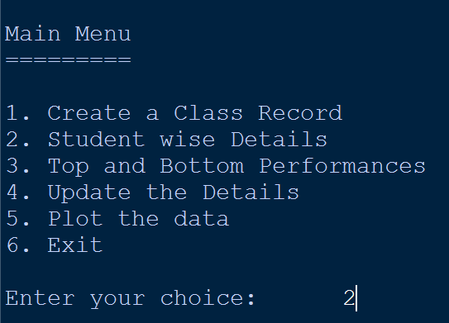

7.2 CSV FILE

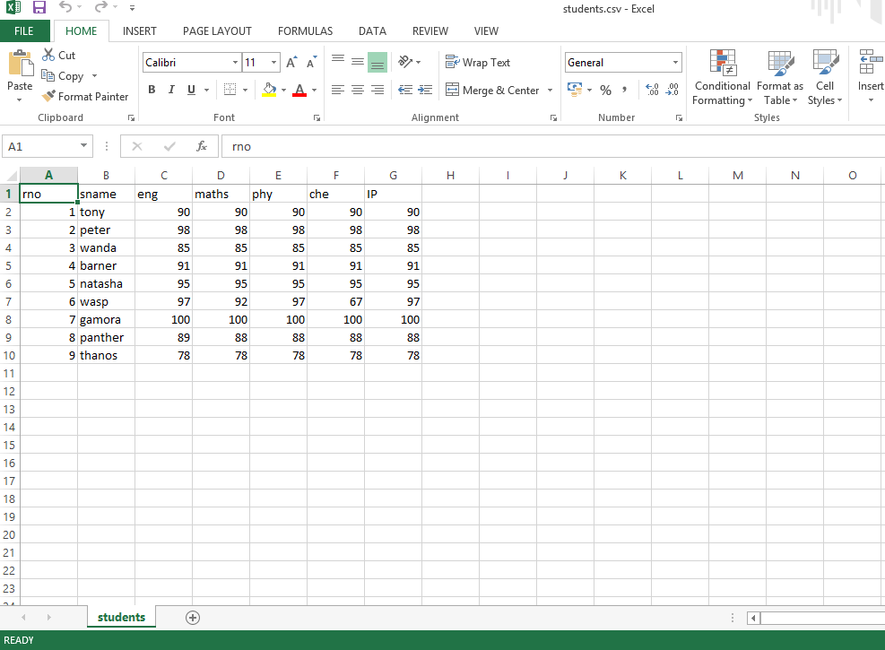

7.3 DATAFRAME DISPLAYED FROM CSV

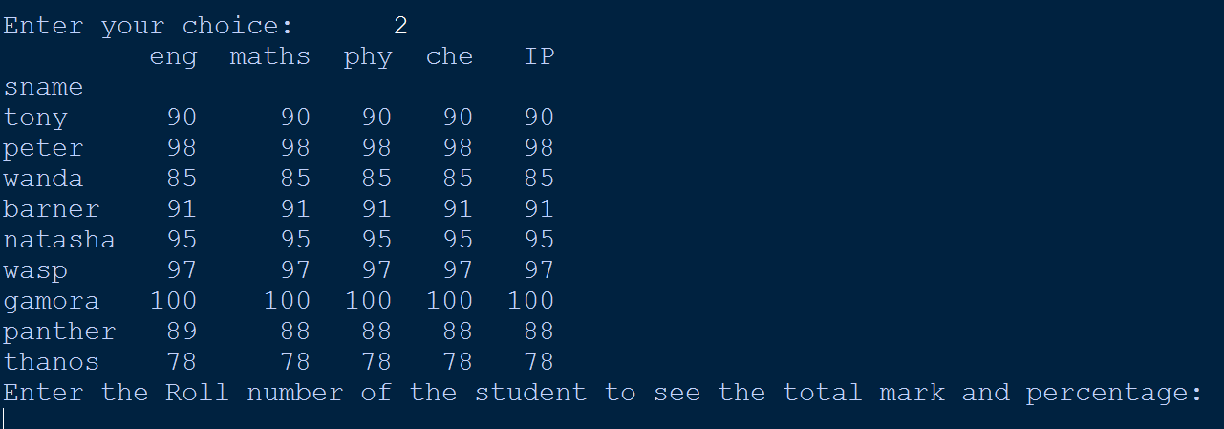

7.4 RUN-TIME SAMPLE OUTPUT WINDOWS

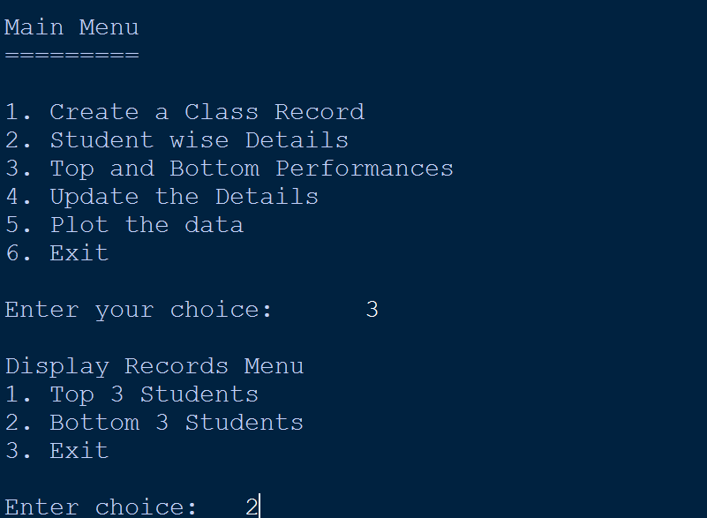

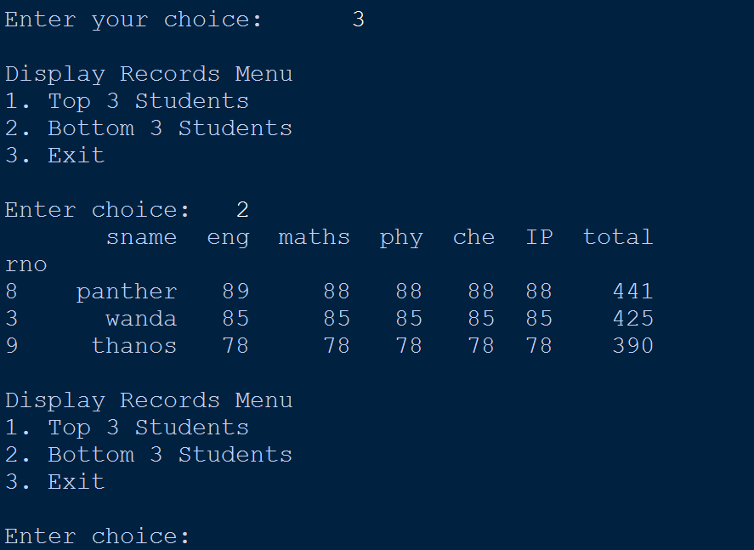

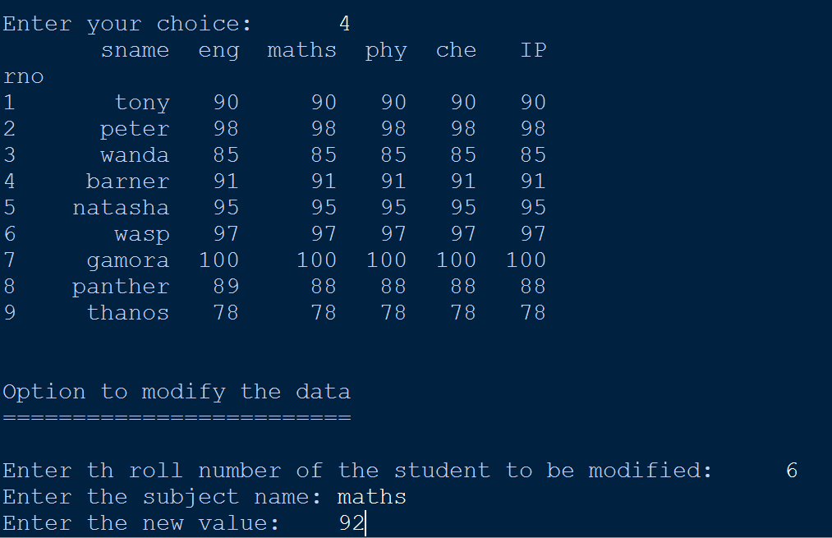

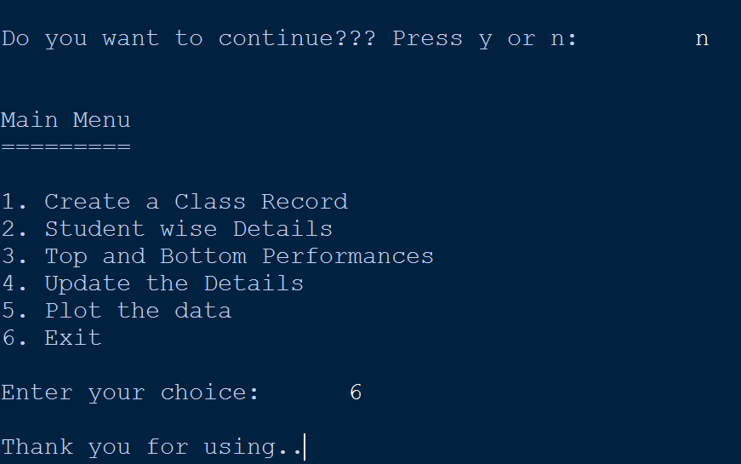

7.5 OUTPUT CHART

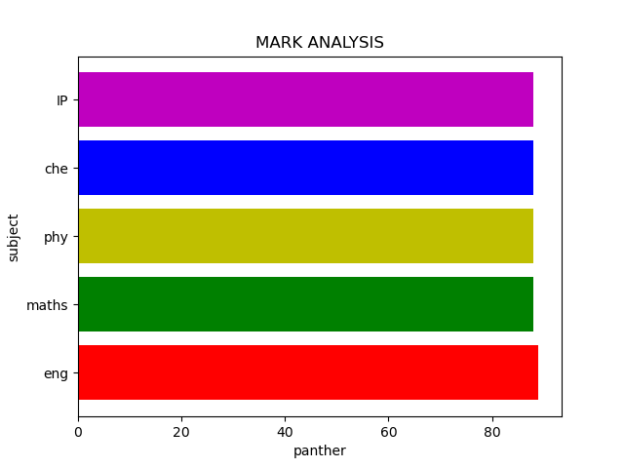

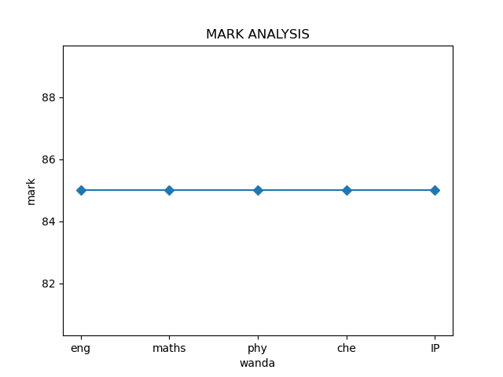

CHAPTER 8
CONCLUSION

Data Science / Analytics is all about finding valuable insights from the given dataset. This program is helpful in analysing the marks obtained by the students in different subject. The user – a teacher or a student can enter the data and the program itself generates a DataFrame and saves it as a csv file which is highly portable. The program allows the user to modify the data if necessary. The user can also analyse the marks in percentage and also allows to display the top three, bottom three based on the total mark. This helps the end-user to easily identify the highest and lowest performance.
Also, it can be used to plot different graphs like bar graph and line plot of individual students. This helps in improving the performance as an individual and class performance. That tells us two things: Python Expressions are very crispy in terms of its syntax and the second thing is, it doesn’t need to be tens and hundreds of line to bring out a valuable insight — just a few lines could do the magic — if you’re asking the right question!

CHAPTER 9
REFERENCES

- Informatics Practices - Class XII By : Sumita Arora

- Website: https://www.w3resource.com

- Website : https://pandas.pydata.org/pandas-docs/stable/reference/api/pandas.read_csv.html

- Website : www.python.org

